**Summit Station Weekly Science Report**

**Reporting Period:**  December 24 – December 30, 2018

**Completed by:** Gus Allen, Troy Nave

**Comments:**

Techs took advantage of low wind conditions and comparatively mild temperatures to remove a large amount of accumulated rime from the TAWO and 16m towers this week, and to change the Surface Ozone filter on the TAWO tower.

The government shutdown has prevented access to NOAA weather data archives, and so the statistical summary of weather conditions or north wind periods is an estimate based on visual interpretation of the weather data plots. Wind speeds at Summit ranged from 3 m/s, recorded on 2018-12-30, to 13 m/s on 2018-12-25. Temperatures ranged from a low of -47˚C on 2018-12-29 to a high of -19˚C on 2018-12-25.

Summit experienced no low winds last week, and no north winds last week.

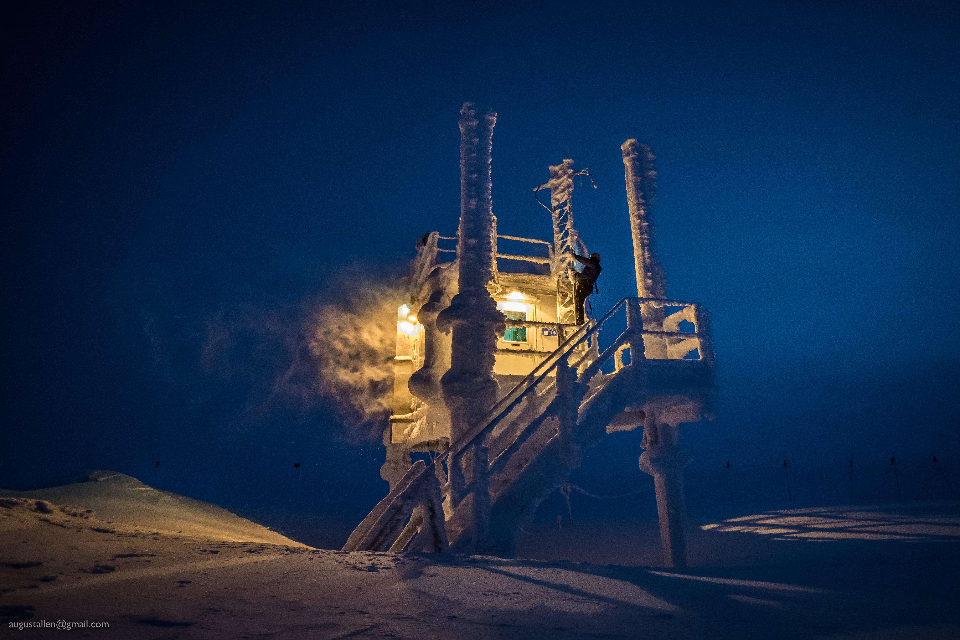

Troy “The Human Spider” Nave removes accumulated rime from the TAWO tower.

**Please visit the clean air log at ftp://isr.sri.com/pub/summit/ftp/science/clean_air_traffic/**

|  |  |
| --- | --- |
| **Facilities** | **Comment** |
| TAWO | Rime ice was removed from both TAWO and 16m Met towers. |
| MSF | Ongoing minor adjustments are being made to heating and ventilation systems in an effort to reduce power consumption. |
| Green House |  |
| **Experiment** | **Notes** |
| NOAA CCGG flasks | Comment:  Date performed: 2018-12-27 |
| NOAA HATS flasks | Comment:  Date performed: 2018-12-24 |
| NOAA Surface Ozone | Comment: Calibrated on 2018-12-25. Filter changed on 2018-12-27.  % of time operating: 100% |
| NOAA Aethelometer | Comment: Offline since 2018-01-10. Instrument offsite for repair.  % of time operating: 0% |
| NOAA Meteorology | Comment: Rime ice removed from Met tower and all instruments.  % of time operating: 100% |
| NOAA CLAP & Neph | Comment: Nephelometer span check completed 2018-12-11.  % of time operating: 100% |
| Radionuclide Filter | Comment: Changed every other day  % of time operating: 100% |
| Aerosol DRUM Sampler | Comment:  % of time operating: 100% |
| Bamboo Forest | Comment:  Date performed: 2018-12-28 |
| SnowFox | Comment:  Date performed: 2018-12-26 |
| ICESat Accumulation | Comment:  Date performed: 2018-12-15 |
| GFZ Potsdam Seismometer | Comment:  % of time operating: 100% |
| DTU Magnetometer | Comment:  % of time operating: 100% |
| UNAVCO | Comment: |
| Helmig CUGC | Comment:  % of time operating: 100% |
| Steffen Tower Instruments | Comment:  % of time operating: 100% |
| Steffen Solar Instruments | Comment:  % of time operating: 100% |
| ICECAPS-ACE Total Sky Imager | Comment: Offline for the winter  % of time operating: 0% |
| ICECAPS-ACE Radiosonde | Comment:  Dates performed: Twice daily. |
| ICECAPS-ACE MWR | Comment:  % of time operating: 100% |
| ICECAPS-ACE SODAR | Comment:  % of time operating: 100% |
| ICECAPS-ACE POSS | Comment:  % of time operating: 100% |
| ICECAPS-ACE MASC | Comment: Instrument is offsite for repair and is due to return Summer 2019.  % of time operating: 0% |
| ICECAPS-ACE MMCR | Comment:  % of time operating: 100% |
| ICECAPS-ACE CAPABL | Comment: Instrument is presently operating normally using laser 2.  % of time operating: 100% |
| ICECAPS-ACE MPL | Comment:  % of time operating: 100% |
| ICECAPS-ACE Ceilometer | Comment:  % of time operating: 100% |
| ICECAPS-ACE PAERI | Comment:  % of time operating: 100% |
| ICECAPS-ACE IcePIC | Comment: No images captured this week  Date(s) performed: |
| ICECAPS-ACE CLASP | Comment: Instrument removed from MSF for service.  % of time operating: 0% |
| ICECAPS-ACE CPC | Comment: Instrument removed from MSF for service.  % of time operating: 0% |
| ICECAPS-ACE OPC | Comment: OPC status ambiguous because ACE laptop is unresponsive. Instrument appears functional but there is no way to verify proper data collection.  % of time operating: % |
|  |  |  |
|  |  |  |